# 

# Sudin’s guide on TFR icons

Hi everyone, I'm S U D I N, the head of icons in “The Fire Rises” mod.

If you have opened this guide then you have at least once asked yourself the question "How to make icons in TFR style?", or you have joined the dev team, in this guide you will finally get the answer.

Let's start with the basics: to create an icon (any icon) you need Photoshop, of course you can try to make it in paint.net, but I **personally** do NOT recommend it.

(Alfred was here! Use Photoshop you lazy cunts)

Useful programs/sites:  
https://www.remove.bg - helps to remove the background (massive time saver), but still, sometimes you will have to work by hand yourself. For this, I suggest using the quick selection tool within Photoshop, once clicked at the top of your window a button saying ‘Select Subject’ should appear and most of the times that should give you a good result (may vary depending on whatever version of photoshop you are using).

Any program that converts all sorts of dds and webp, in a format suitable for Photoshop. In the search for assets you will often meet unsupported formats. Please, be mindful of what websites you visit in this endeavor, as some of them may be riddled with adware or other viruses for your PC.

I would like to note that this guide is for users who have heard of creating GFXs and have at least a general understanding of Photoshop.

Step 1:

Open Photoshop, and create a canvas at 140x140 pixels. I advise you to change the background to any color other than white, usually it is best to do dark red or light gray.

It's important to leave space, don't fill the canvas completely, an example, and desirable borders below by picture

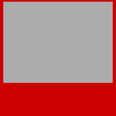

YES, it is important to leave more space at the bottom, this is to keep the icon from overlapping the focus text in the tree.

### Step 2:

Now, of course, you need an idea for an icon, and an asset for it. For this guide, I'm going to use Bust.

Open your asset in photoshop, and copy it to your canvas and reduce it to the size you want.

VERY IMPORTANT, don't forget to convert your assets to smart objects before scaling!!! A smart object helps to preserve quality and manipulating the asset is easier. You can easily tell if your asset is a smart object by having this paper icon next to it in the layer window.



Alternatively, you can simply take an asset from a folder, and drag it onto your canvas with your mouse, then it will automatically become a smart object and be calibrated to the size of the canvas.

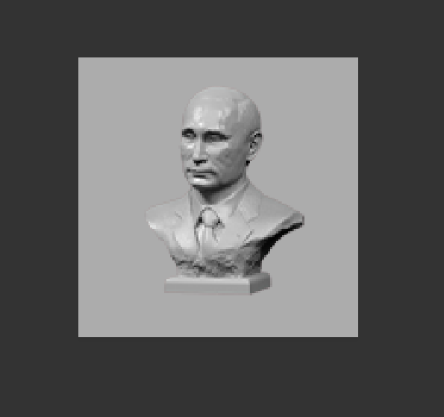

### Step 3:

Now we need to apply base styles to this bust. I could go on and on about the different settings, but being the lazy ass that I am, I'll just give you a link to the styles I have installed.

Of course, they're not panacea, and you'll still often have to adjust them to suit your desires and visions, but with their help, you'll quickly get the hang of it.

<https://drive.google.com/file/d/1sGCYUmX-bw9-HUHzdsR7e6Q6Xq9RX17X/view?usp=sharing>

RedOtaku uses this  
<https://drive.google.com/file/d/1Uc9xufkxOQVcNTICcyvgM6RMdFHhR4rd/view?usp=sharing>

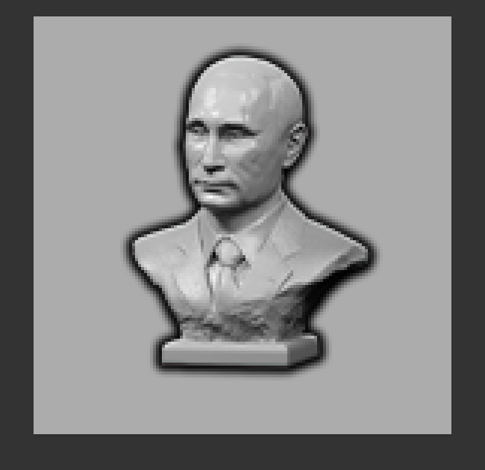

As you can see, there is a ***fat shadow*** on the asset, this is probably the most important thing that should be, although the strength of the shadow, and its transparency can vary.

### Step 4:

Now you can start with the secondary improvements, which of course include brightness/contrast, saturation, richness, gradients, and other image correction. Also, I would like to recommend using the **camera raw filter** for editing, which can be found in the **filter** tab.

#### Step 4.1:

Our style also makes frequent use of **gradient** overlays. These can easily be applied either through the **layer style menu**, or as a separate layer using this icon**** that should be on the right side of your workspace. You can either use premade gradients or make your own.

**It's always worth keeping aesthetics in mind, for example the communist icon will have a red-yellow tint. Fascists - darker tones, and the democratic ones most often fit the colors of the ideologies in our mod, but you can create gradient palettes with national specifics, making them more exclusive.**

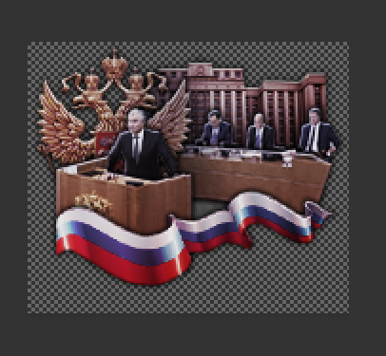

Example: A weak blue-red gradient palette is used on this focus icon.

### Step 5:

As you know, the TFR style is perhaps different in that we have crossed the rubicon and almost completely abandoned generic backgrounds from different GFX folders, whether it is a wreath, leaves, screws, pins, rhombuses, or just circles.

In TFR style they are replaced by other assets, often a photo or painting can be used, with the edges trimmed with a **soft eraser**.

The edges of the assets are also **soft erased**, in the places necessary for this, usually along the edges, or to trim the residual top. To do this, it is best to put the layers you want to "trim" in a layer group and create a mask layer on it, where you will erase.

This is not necessary if you think the icon will look better without it. **Also, don't just trim the whole layer by putting it in one group, you should always respect the dynamics and aesthetics.**

## ***Frequently Asked Questions****

Q: Sudin, when I use a smart object, I lose the ability to do anything on the asset layer, especially to use the eraser.

A: When using an Asset, you'll get a lot of help by applying a mask layer. For more drastic changes, I suggest just making a copy of the smart object and turning it into a normal layer, then you have room for error and trial and error. Alternatively, you can just open the smart object and edit on its canvas.

Q: Sudin, when I do gradient/color, I am left with a white embossing line on the asset, how to fix it - dima 5 years old

A: Merging a layer or layers into one group, and overlaying your effects on the group itself, can help.

Q: Sudin, your icons are PARTICULARLY always over the 140x140 size!

A: You're right, often the width of an icon can be as wide as 160-170 pixels, depending on the idea we put into it and the scale of inspiration. Don’t let rules restrict your ideas, sometimes this works, other times not so well but, you shouldn’t be afraid to experiment!

But this only applies to the width! The height of the icon should remain constant, except for an error of 3-5 pixels.

Q: Sudin, thanks for the psd that weighs 500 mb because of your fucking smart objects and groups

A: Art requires sacrifice, space for a videya games on your PC is also a sacrifice.

THIS WILL BE UPDATED DEPENDING ON NEW QUESTIONS.